Name: ______________________________

Field Day Champion
by Kelly Hashway

Andy smiled as he and his field day team stepped up to their last activity. They were in first place, and Andy could already feel the medal around his neck.
“How exciting!” Mrs. Emory said. “You two teams are tied with the highest score of the day.”
“Tied?” Andy said. “But we beat them at the relay race.”
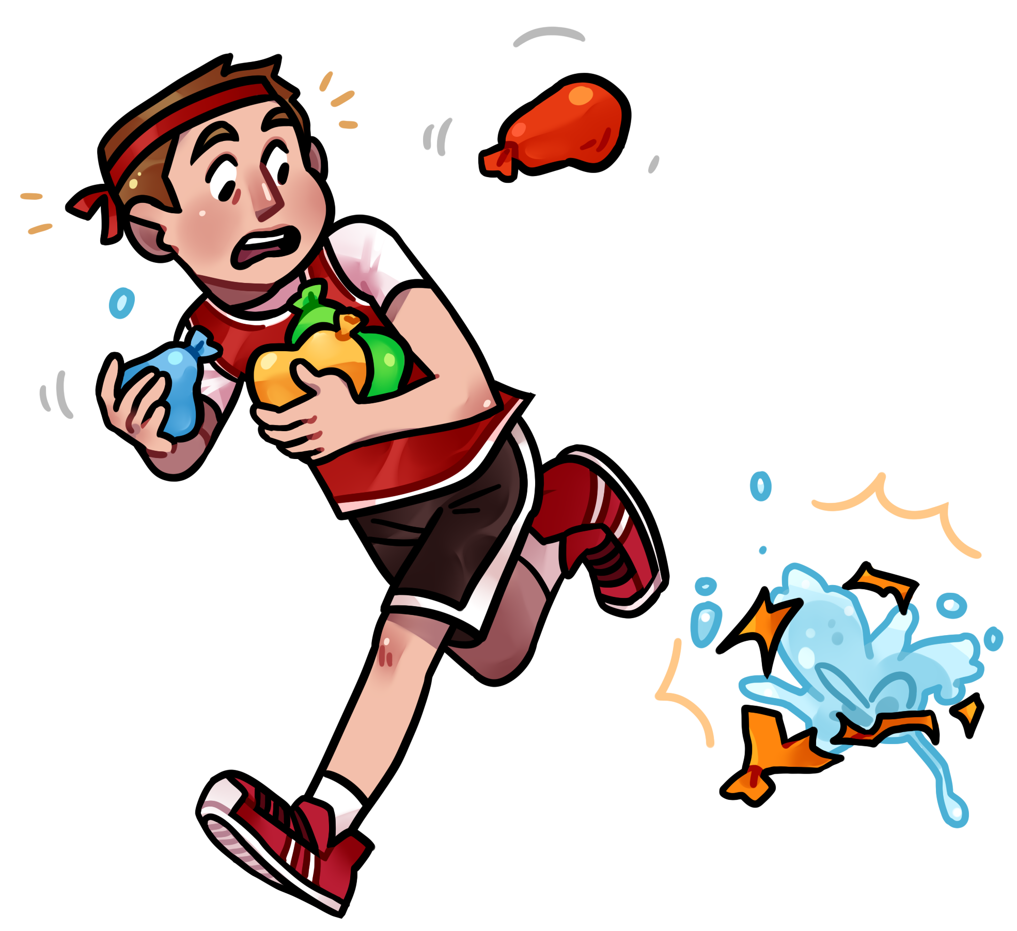
“Yes, but that was their only loss,” Mrs. Emory said. “Your team also has one loss, so you are both tied for first place.”
Andy crossed his arms in front of his chest. He didn’t want to think about the balloon toss. He’d been the first one to drop his balloon.
“This event is a hula hoop challenge,” Mrs. Emory said, handing everyone a hula hoop.
“Are we supposed to see how far we can roll them?” Andy asked.
“No. Your challenge is to hula hoop for as long as possible. Once your hoop hits the ground, you will be disqualified. The last person hula hooping will win the event for their team.”
Andy’s eyes widened. He’d never hula hooped before. He looked at the rest of his team. Becky seemed confident and so did Cory. They only needed one person to do well in order to win.
“Can we start?” asked Rachelle, the other team’s captain. She must have done this before because she was excited about the challenge.
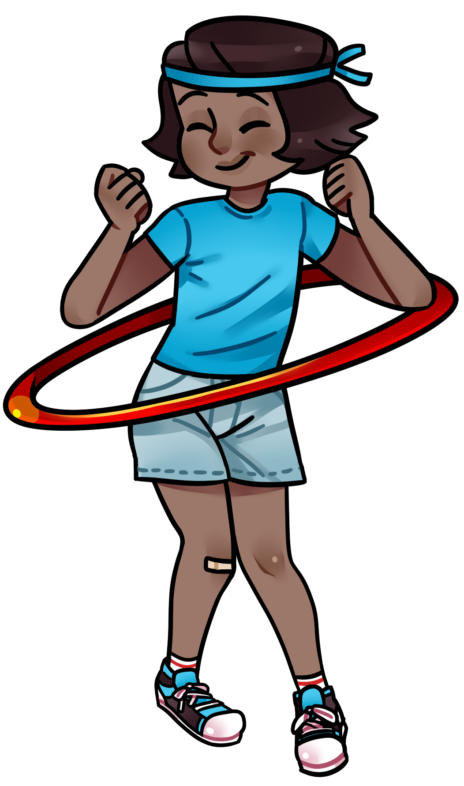
Mrs. Emory blew her whistle. “Begin!”
Andy watched Rachelle and mimicked everything she did. But no matter how hard he tried, the hoop wouldn’t stay up. It bobbled and fell to his ankles. He stepped aside and cheered for Becky and Cory who were the only ones left to battle Rachelle.
Becky sneezed and her hoop toppled to the ground. Andy grumbled, but he started cheering even louder for Cory. Andy stared at Rachelle. She looked so relaxed as the hoop twirled around her. Her team was chanting her name, and it took Andy a moment to realize Cory had dropped his hoop. The challenge was over, and Rachelle had won, which meant Andy’s team had lost. But Andy couldn’t help cheering for Rachelle as she continued to hula hoop.
Rachelle was still hula hooping when Mrs. Emory gave out the medals. Andy wore his second place medal with pride as he congratulated Rachelle, the true field day champion.

About the Author
Kelly Hashway's picture book, May the Best Dog Win, is now available!

Dash has the perfect life until the Super Sweeper 5000 shows up. Sweeper runs
all over the house sucking up the leftover food scraps,
and he even gets his own room! But Dash won't give up his place as
the favorite dog without a fight.

Hashway, Kelly. May the Best Dog Win. ISBN: 9780984589081
Name: ______________________________

Field Day Champion
by Kelly Hashway

1. The second sentence of the story says:

They were in first place, and Andy could already feel the medal
around his neck.

What does this mean?

a. Andy could feel the weight of the medal hanging from his neck.
b. The medal on Andy's neck was bothering him.
c. Andy wanted to take off his medal so he could hula hoop better.
d. He was close to winning a medal, and he imagined himself wearing it.

2. What were the names of Andy's teammates?

____________________________________________________________________________________

3. Do you think Andy was a good sport or a sore loser? Explain.

____________________________________________________________________________________

____________________________________________________________________________________

4. How did Andy feel when he received his medal?

a. sad b. angry
c. proud d. confused

5. Read the following sentence from the story.

Andy watched Rachelle and mimicked everything she did.

Choose the best definition for the underlined word.

a. made fun of b. copied
c. talked about d. cheered for
Name: ______________________________

Field Day Champion
by Kelly Hashway

Fill in the missing letters to create a word from the story. Then, write the full word on the line. Be sure you spell each word correctly.

1. ___ a ___ ___ o ___ ___ 1. _________________________________
clue: rubber sack that is filled with air or water

2. ___ u ___ ___ ___ o ___ ___ 2. _________________________________
clue: large plastic toy ring

3. ___ ___ d e ___ ___ d 3. _________________________________
clue: became wider

4. ___ i ___ i ___ ___ ___ d 4. _________________________________
clue: copied

5. ___ ___ u ___ ___ l ___ d 5. _________________________________
clue: complained or showed unhappiness

6. ___ a ___ t ___ ___ 6. _________________________________
clue: compete against

7. ___ ___ ___ ___ u ___ ___ i f ___ e ___ 7. _________________________________
clue: removed from the game

Name: ______________________________

Field Day Champion
by Kelly Hashway

In the story, “Field Day Champion,” Andy becomes so amazed by the hula hooping talent of his opponent, Rachelle, that he forgets to be upset when she wins the competition.
Instead, Andy learns that celebrating someone's victory is much better than being a sore loser.

Tell about a time when you chose to be happy for somebody else's victory rather than being a sore loser.

____________________________________________________________________________________________________

____________________________________________________________________________________________________

____________________________________________________________________________________________________

____________________________________________________________________________________________________

____________________________________________________________________________________________________

____________________________________________________________________________________________________

____________________________________________________________________________________________________

____________________________________________________________________________________________________

____________________________________________________________________________________________________

____________________________________________________________________________________________________

____________________________________________________________________________________________________

____________________________________________________________________________________________________

____________________________________________________________________________________________________

____________________________________________________________________________________________________

____________________________________________________________________________________________________

____________________________________________________________________________________________________

____________________________________________________________________________________________________

____________________________________________________________________________________________________
ANSWER KEY

Field Day Champion
by Kelly Hashway

1. The second sentence of the story says:

They were in first place, and Andy could already feel the medal
around his neck.

What does this mean?

a. Andy could feel the weight of the medal hanging from his neck.
b. The medal on Andy's neck was bothering him.
c. Andy wanted to take off his medal so he could hula hoop better.
d. He was close to winning a medal, and he imagined himself wearing it.

2. What were the names of Andy's teammates?

Becky and Cory

3. Do you think Andy was a good sport or a sore loser? Explain.

He was a good sport because he continued to cheer for Rachelle even after his team had lost.

4. How did Andy feel when he received his medal?

a. sad b. angry
c. proud d. confused

5. Read the following sentence from the story.

Andy watched Rachelle and mimicked everything she did.

Choose the best definition for the underlined word.

a. made fun of b. copied
c. talked about d. cheered for
ANSWER KEY

Field Day Champion
by Kelly Hashway

Fill in the missing letters to create a word from the story. Then, write the full word on the line. Be sure you spell each word correctly.

1. b a l l o o n 1. balloon
clue: rubber sack that is filled with air or water

2. h u l a h o o p 2. hula hoop
clue: large plastic toy ring

3. w i d e n e d 3. widened
clue: became wider

4. m i m i c k e d 4. mimicked
clue: copied

5. g r u m b l e d 5. grumbled
clue: complained or showed unhappiness

6. b a t t l e 6. battle
clue: compete against

7. d i s q u a l i f i e d 7. disqualified
clue: removed from the game

